Ideation Phase

Define the Problem Statements

|  |  |
| --- | --- |
| Date | 02 October 2022 |
| Team ID | PNT2022TMID31665 |
| Project Name | NEWS TRACKER APPLICATION |
| Maximum Marks | 2 Marks |

**Customer Problem Statement Template:**

|  |  |  |  |  |  |
| --- | --- | --- | --- | --- | --- |
| **Problem**  **Statement (PS)** | **I am (Customer)** | **I’m trying to** | **But** | **Because** | **Which makes me feel** |
| PS-1  24/7 Working people find it hard for reading the news. | Ranjani is an Employee who wants to read newspaper, without any hassle while travelling because he  doesn’t want to carry the physical  newspaper. | I am looking for  the easier method to read news. | I am unable to find the time to read news. | It is challenging to manage time on working days. | I feel being not updated with the news and current affairs that revolving around me. |
| PS-2 Finding the right content about specific news topics in single platform is challenging. | Shifa is an HR who want get updated in the company recruitments and business- related news in a single application or website. | I am looking for the right website or Application which update and notify me in every aspect. | I am unable to find the right application or website. | It is challenging and hard to find single place to find the news. | I feel redirected to some other news which consumes a lot time by giving me irrelevant data. |

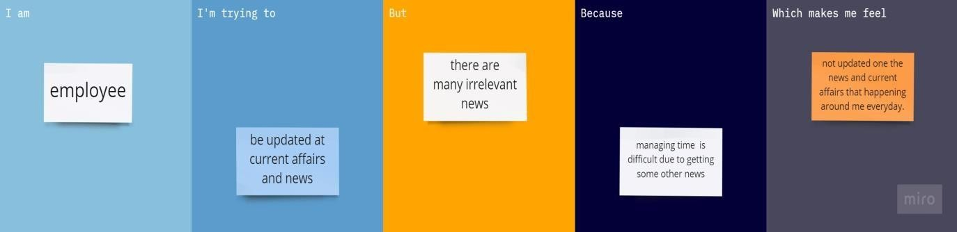

Reference – [https://miro.com/app/board/uXjVPTG6-EE=/?share_link_id=123644614095](https://miro.com/app/board/uXjVPTG6-EE%3D/?share_link_id=123644614095)